**1. Sign in to AWS Management Console:**

* Go to the [AWS Management Console](https://aws.amazon.com/console/).
* Sign in with your AWS credentials.

**2. Navigate to Amazon Redshift:**

* In the AWS Console, search for **Redshift** in the search bar and click on **Amazon Redshift**.

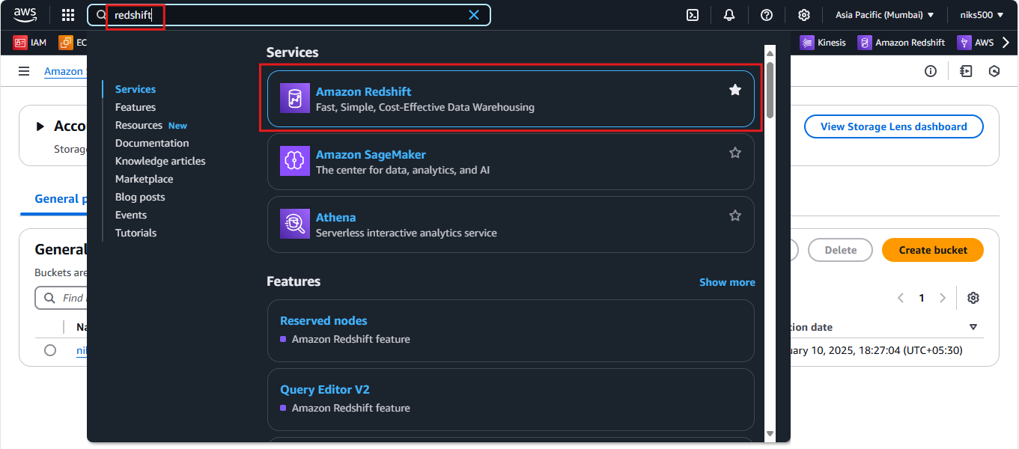

**3. Launch a New Cluster:**

* In the Amazon Redshift dashboard, click on **Create cluster** to start the setup process.

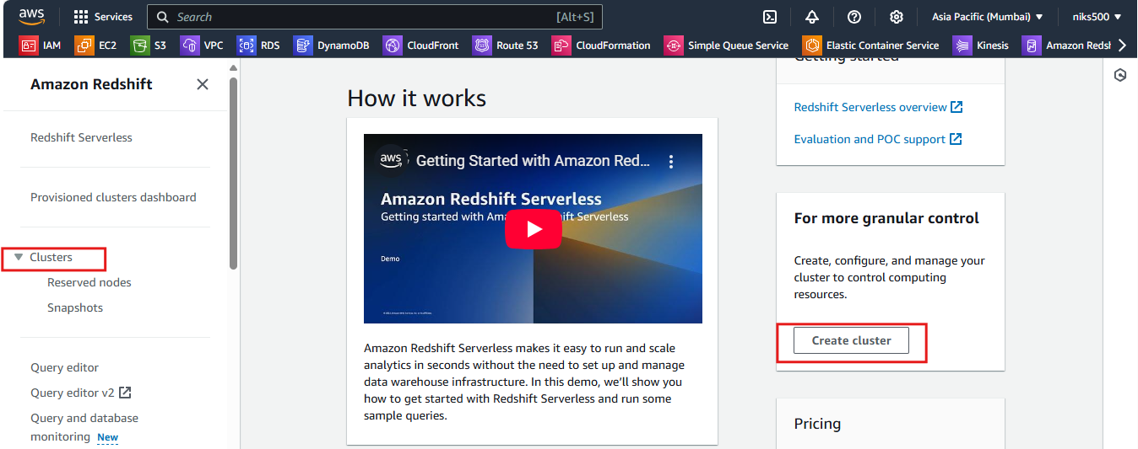

**4. Configure Cluster Details:**

* **Cluster Identifier**: Choose a unique name for your cluster (e.g., my-redshift-cluster).
* **Node Type**: Choose the instance type for your cluster. You can select between dense compute (DC) and dense storage (DS) node types. For example:
  + **dc2.large** (low-cost, general-purpose).
  + **ds2.xlarge** (more storage, suitable for large data workloads).

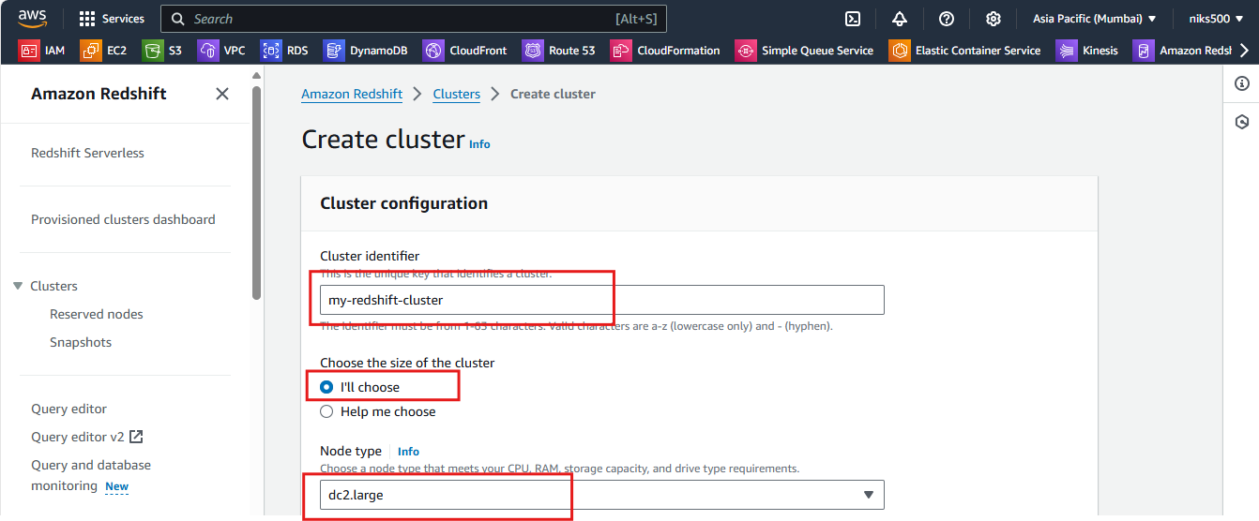

* **Number of Nodes**: Choose the number of nodes for your cluster. A single-node cluster can be used for testing, while a multi-node cluster provides greater performance and scalability.

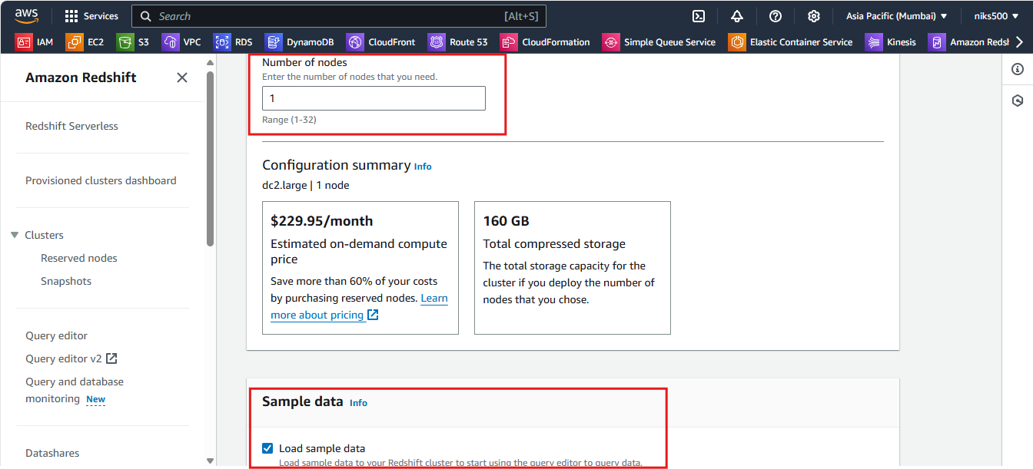

* **Master Username**: Provide a master user name (e.g., admin, awsuser).
* **Master Password**: Set a password for the master user.

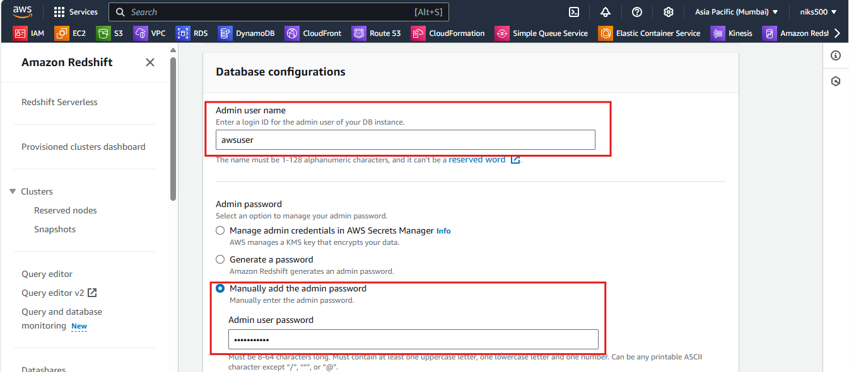

**5. Configure Cluster Settings:**

* **VPC**: Choose a **VPC** (Virtual Private Cloud) for your cluster. If you're unsure, you can select the default VPC.
* **VPC Security Group**: Choose an existing security group or create a new one to control access to your Redshift cluster.
* **Cluster Subnet Group**: Select a subnet group (usually, the default will work).
* **Availability Zone**: You can leave it set to **No Preference** unless you have a specific requirement.

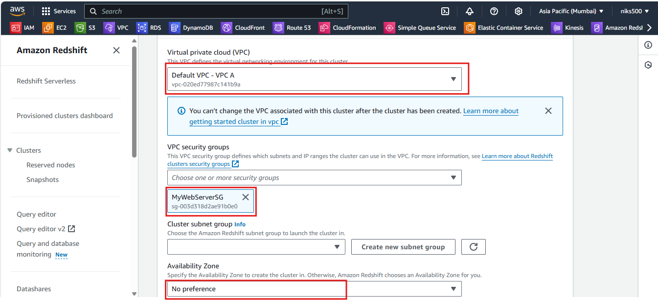

**6. Set Maintenance and Backup Options:**

* **Automated Snapshots**: Choose whether to enable automated backups of the cluster.
* **Snapshot Schedule**: Set a schedule if you want regular snapshots for disaster recovery.

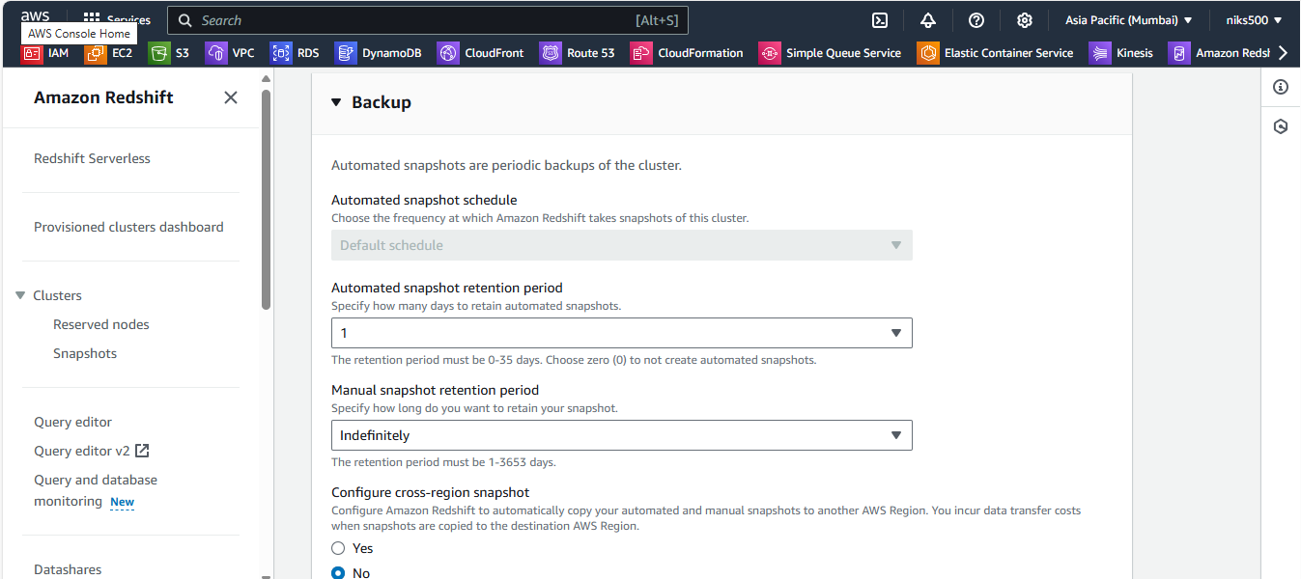

* **Maintenance Window**: Select the preferred time window for cluster maintenance (e.g., when updates can be applied).

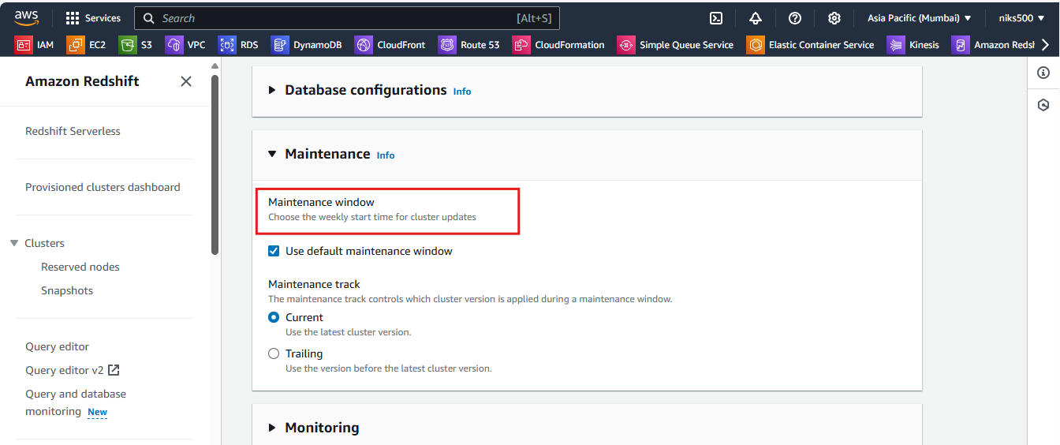

**7. Additional Settings (Optional):**

* **Encryption**: Enable encryption if you want to secure your data at rest.
* **Enhanced VPC Routing**: Enable enhanced VPC routing for better performance in VPC environments.

**8. Review and Launch:**

* After configuring the cluster, review your selections.
* Click **Launch Cluster** to create the Redshift cluster.

**9. Cluster Creation Status:**

* Once the cluster creation process is complete, you will be able to see the cluster’s status as **Available** in the Redshift console.